**LAB ASSIGNMENT 4 – LAB HOURS**

1. Image Quantization (Uniform):

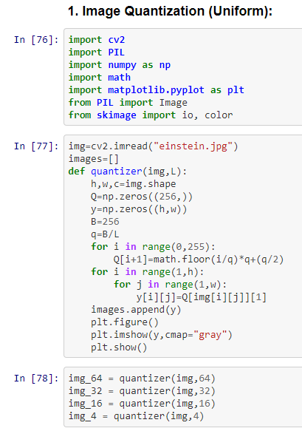

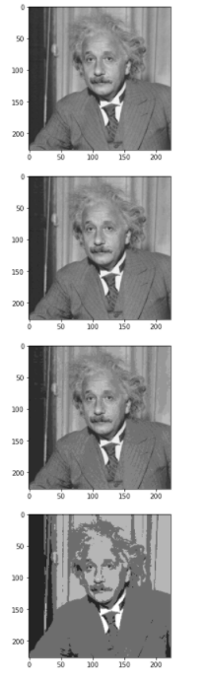

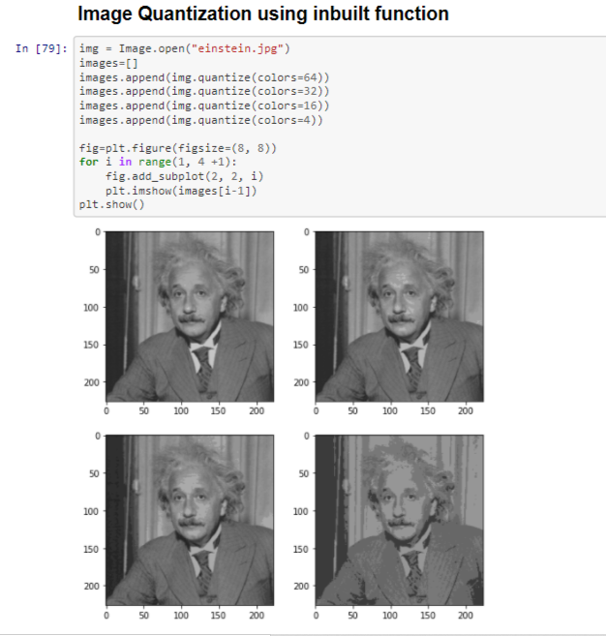

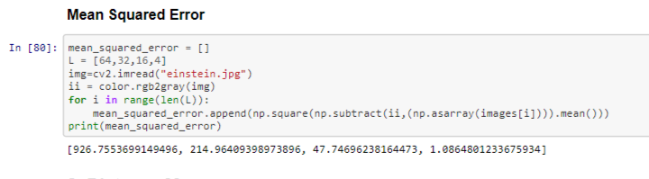

**Q2 - Distance Measures:**

